
HDOC day 10
Prepare the flowchart, pseudocode, algorithm, test case table, write the C code, compile and
execute the program, and test it against the prepared use cases.
Write a C program to input time in seconds and convert it into days, hours, minutes, and
seconds format.
Write a program to input a year and check whether it is a leap year or not.
Question 1)
AimTo write a C program to input time in seconds and convert it into days, hours, minutes, and
seconds.
Algorithm
1)Start.
2)Input time in seconds t.
3)Calculate d = t / 86400.
4)Calculate remaining seconds t = t % 86400.
5)Calculate h = t / 3600.
6)Calculate remaining seconds t = t % 3600.
7)Calculate m = t / 60.
8)Calculate s = t % 60.
9)Display days, hours, minutes and seconds.
10)Stop.
C code
#include <stdio.h>
int main()
{
long t, d, h, m, s;
printf("Enter seconds: ");
scanf("%ld", &t);
d = t / 86400;
t = t % 86400;
h = t / 3600;
t = t % 3600;
m = t / 60;
s = t % 60;
printf("%ld days %ld hours %ld minutes %ld seconds",
d, h, m, s);
return 0;
}

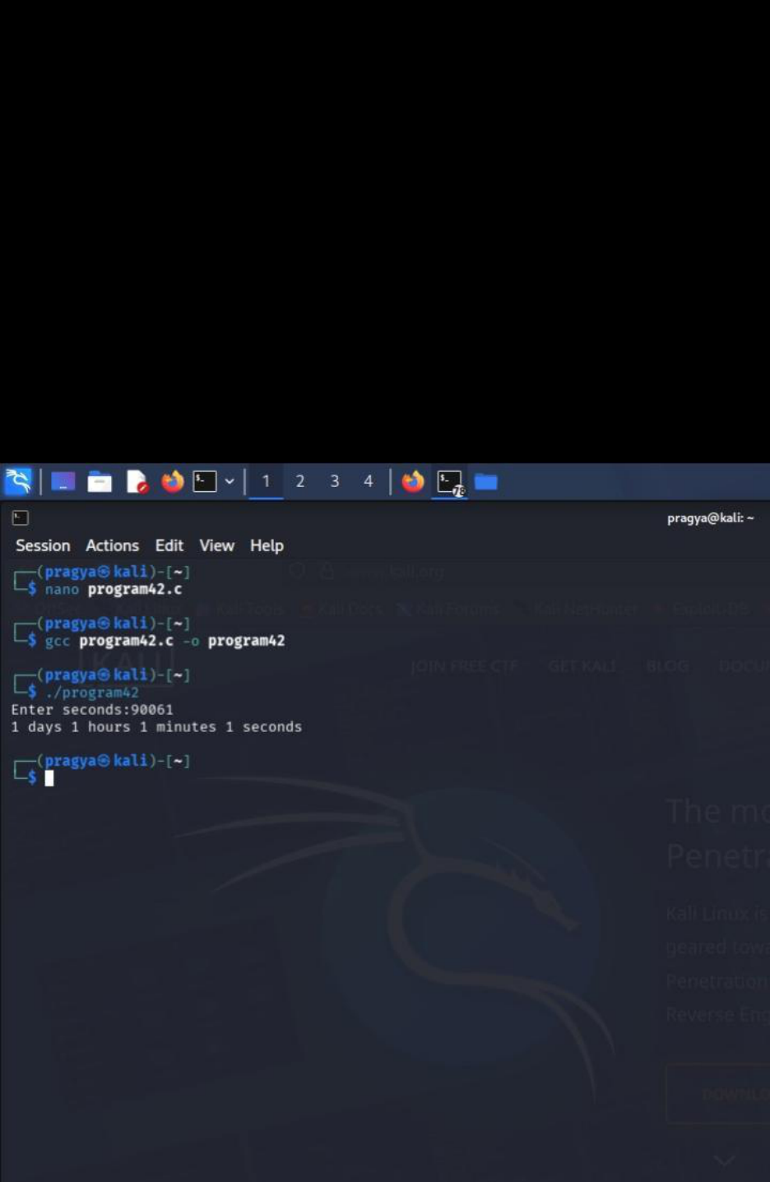

Aim
To write a C program to input a year and check whether it is a leap year or not.
Algorithm
1)start
2)input year y.
3)check if y%400==0or(y%4==0 and y%100!=0)
4)if true display “leap year”
5) otherwise display “not a leap year”
6)stop.
C code
#include<stdio.h>
int main()
{
int y;
printf("Enter year: ");
scanf("%d",&y);
if(y%400==0 || (y%4==0 && y%100!=0))
printf("Leap year");
else
printf("Not a leap year");
return 0;
}

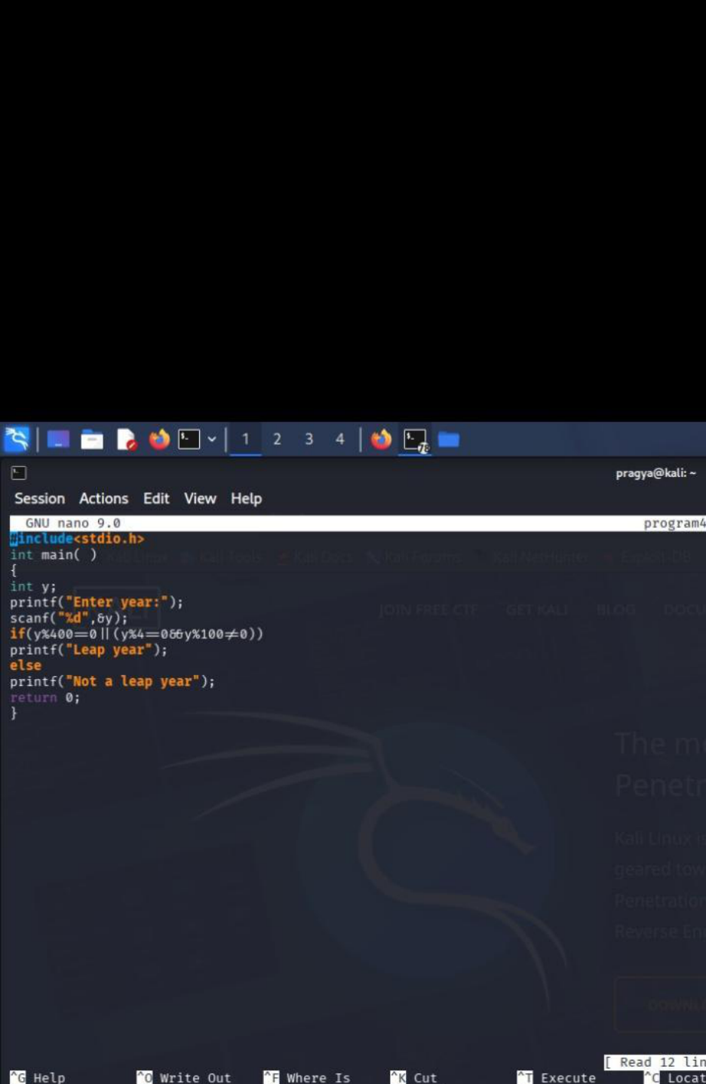

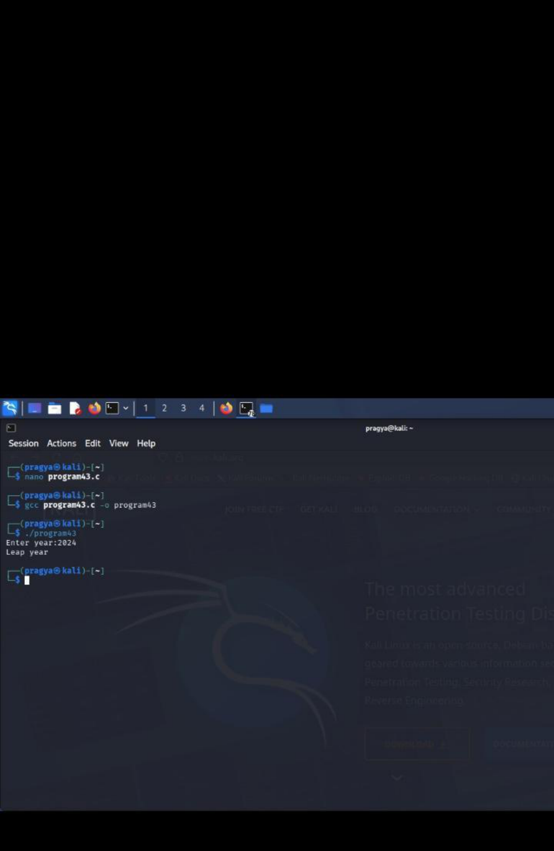

Result:both codes are executed successfully

